**Installing on Windows**

[Download the Anaconda installer](http://anaconda.com/downloads.html).

Double click the installer to launch. (**Python- 3.6 version**)

NOTE: If you encounter any issues during installation, temporarily disable your anti-virus software during install, then re-enable it after the installation concludes.

If you have installed for all users, uninstall Anaconda and re-install it for your user only and try again.

Click Next.

Read the licensing terms and click I Agree.

Select an install for “Just Me” unless you’re installing for all users (which requires Windows Administrator privileges) and click Next.

Select a destination folder to install Anaconda and click Next.

NOTE: Install Anaconda to a directory path that does not contain spaces or unicode characters.

[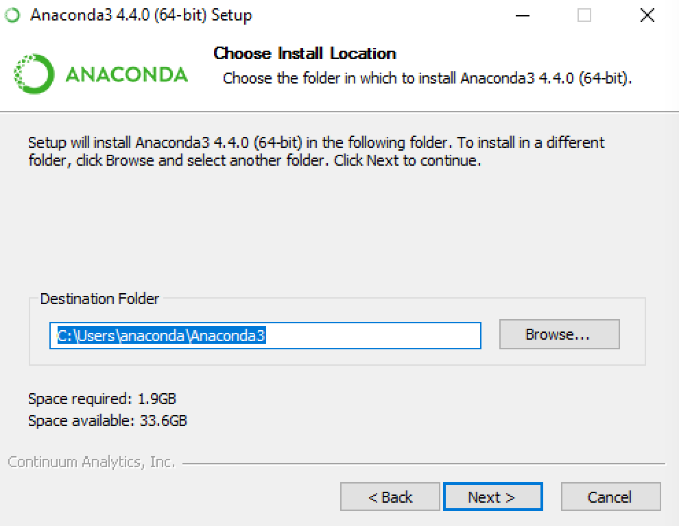](https://docs.continuum.io/_images/install-win-destination.png)

Choose whether to add Anaconda to your PATH environment variable. We recommend not adding Anaconda to the PATH environment variable, since this can interfere with other software. Instead, use Anaconda software by opening Anaconda Navigator or the Anaconda Prompt from the Start Menu.

[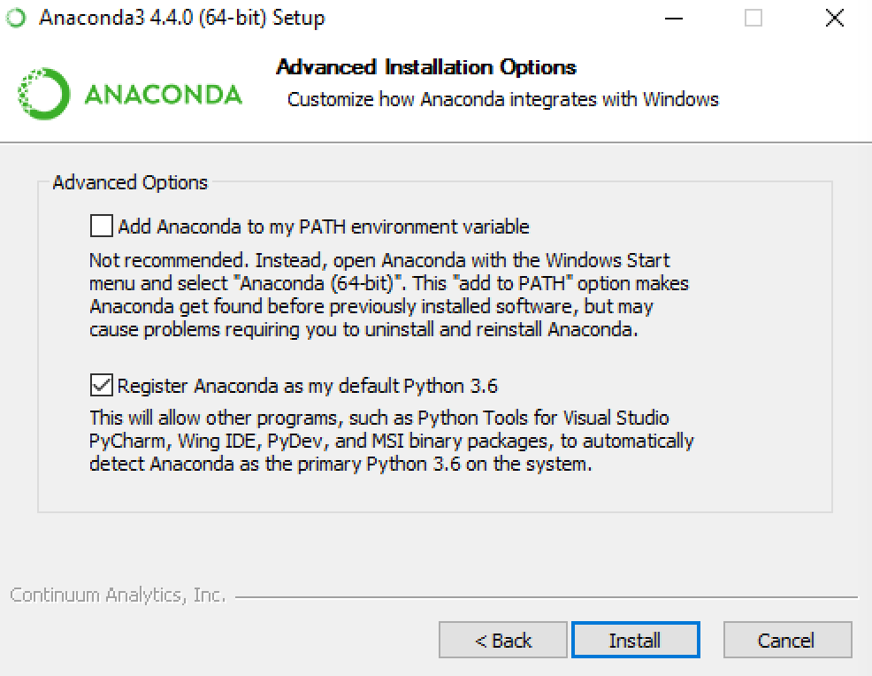](https://docs.continuum.io/_images/install-win-path.png)

Choose whether to register Anaconda as your default Python 2.7. Unless you plan on installing and running multiple versions of Anaconda, or multiple versions of Python, you should accept the default and leave this box checked.

Click Install. You can click Show Details if you want to see all the packages Anaconda is installing.

Click Next.

After a successful installation you will see the “Thanks for installing Anaconda” image:

[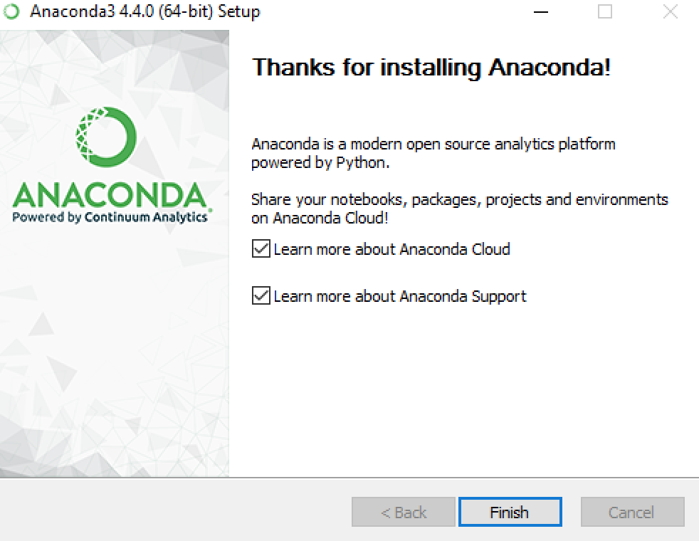](https://docs.continuum.io/_images/anaconda-install-win.png)

Click Finish.

After your install is complete, verify it by opening Anaconda Navigator, a program that is included with Anaconda. From your Windows Start menu, select the shortcut Anaconda Navigator. If Navigator opens, you have successfully installed Anaconda.